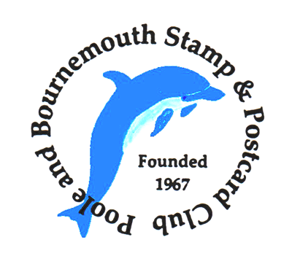

STAMP and POSTCARD FAIR

Saturday, 5th September, 2026
1000 – 1600
The Upton Community Centre
St Dunstan’s Church
Poole Road
Upton
Poole
BH16 5JA

Free entry
Ample free parking
Refreshments available

Over 15 stamp and postcard dealers in attendance
covering your collecting interests

www.poolebournemouthstampclub.weebly.com

